TEST PLAN FOR LOGIN AND REEGISTRATION PAGE
1.Functionality Testing
Test Case | Expected Result
Register with valid details | User account created successfully
Login with wrong password | Access denied message displayed
Register with empty fields | Error message displayed
Register with duplicate username or email | Warning message displayed

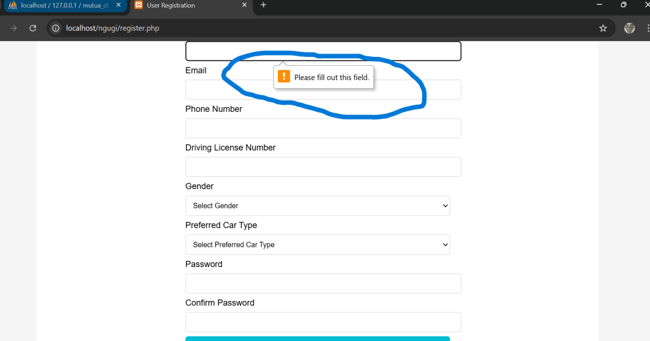

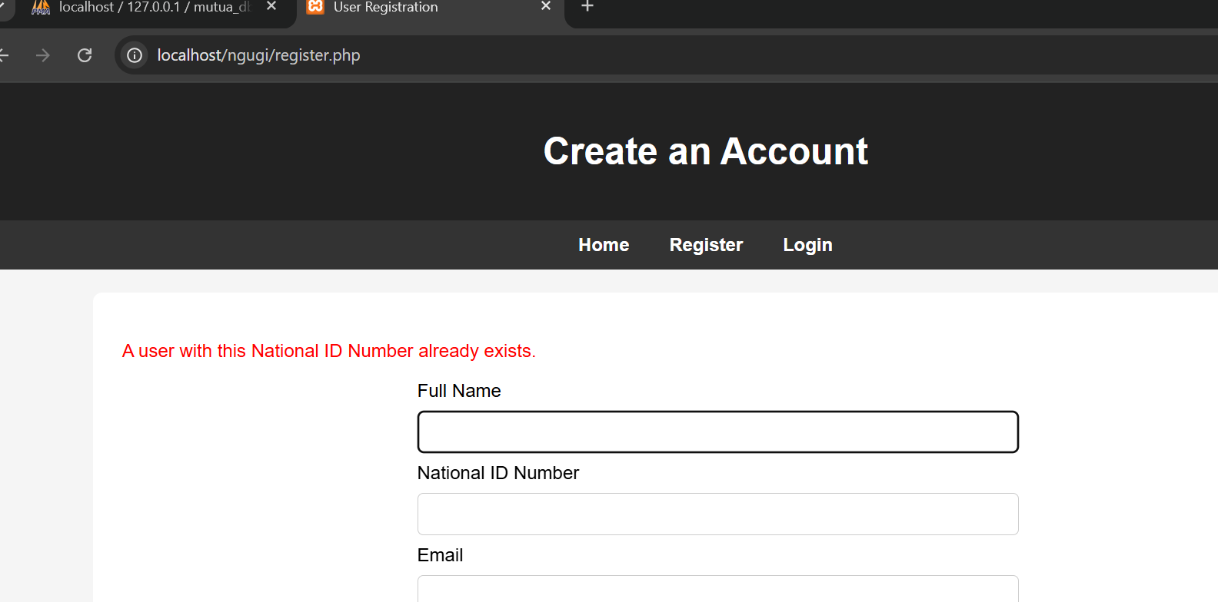

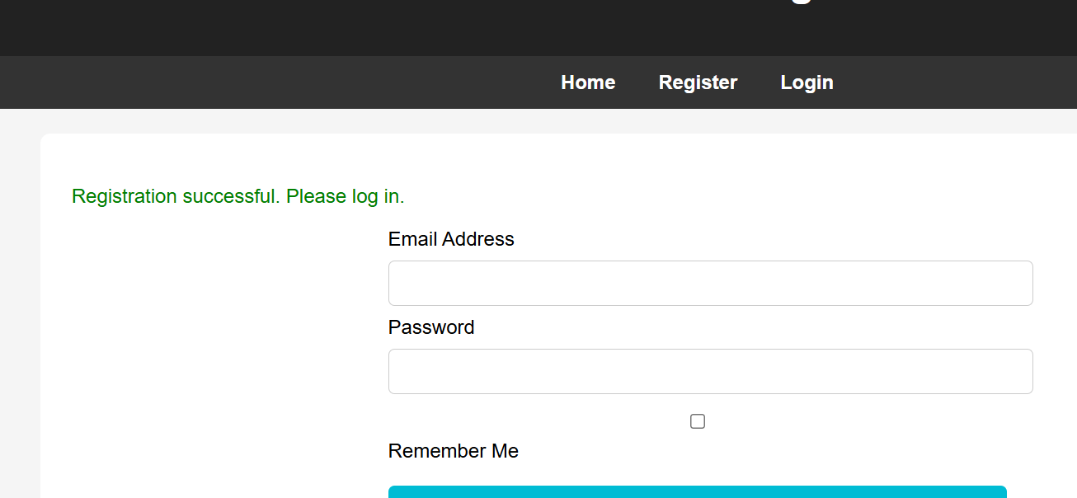

2.Usability Testing
Test Case | Expected Result
Navigation links works properly | Pages open correctly
Registration form is easy to understand | User can fill form without assistance
Error message are clear | User understands the error
Buttons are visible and responsive | User can interact easily

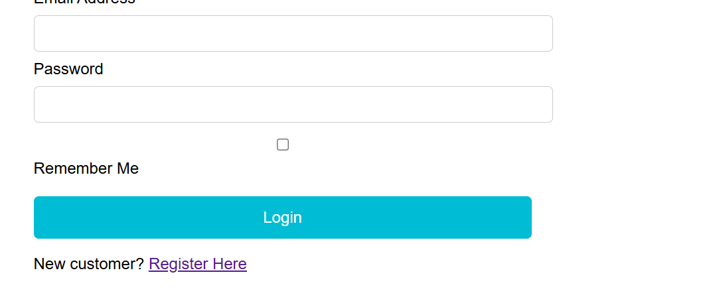



3.Compatibility Testing
Test Case | Expected Result
Website runs on Google chrome | All pages load correctly
Website runs on Microsoft Edge | All pages load correctly
Website displays properly on desktop devices | Content displayscorrectly

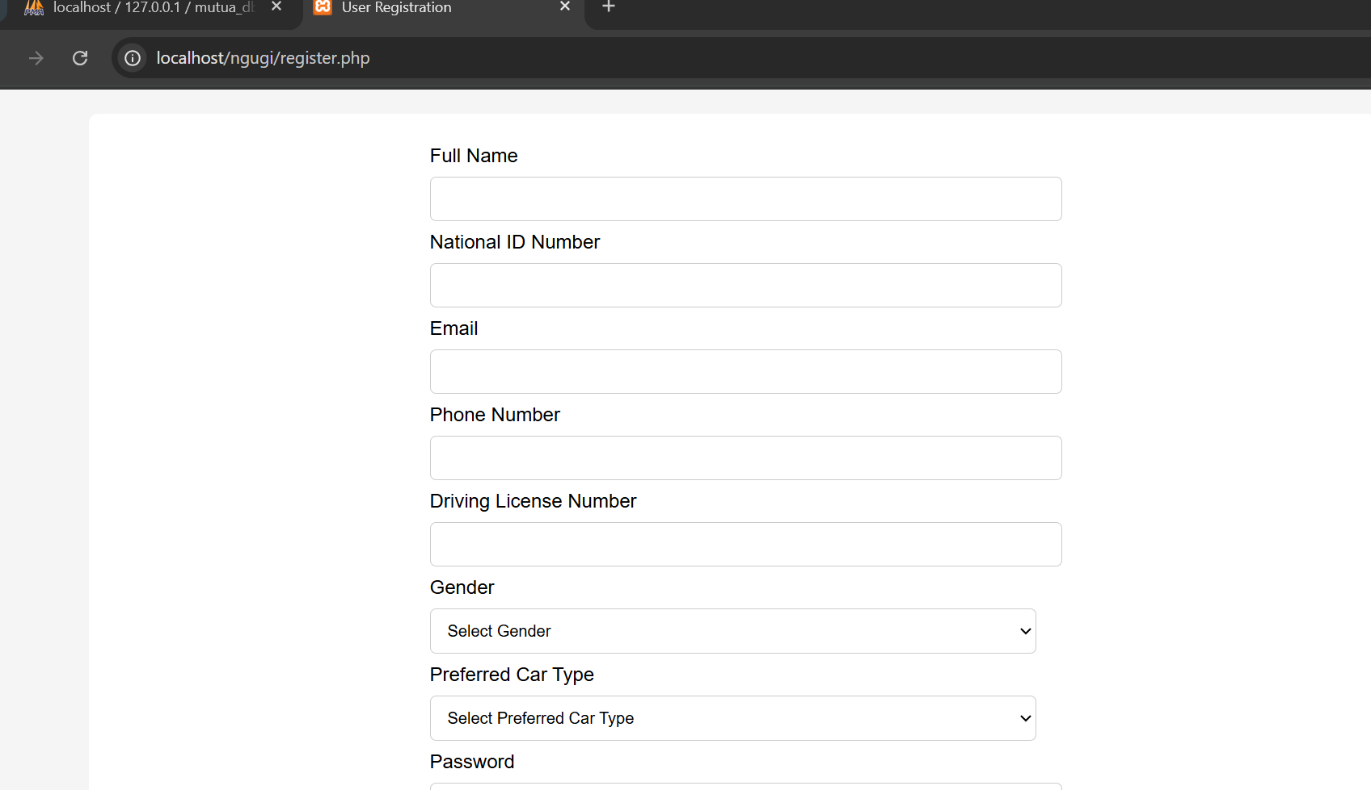

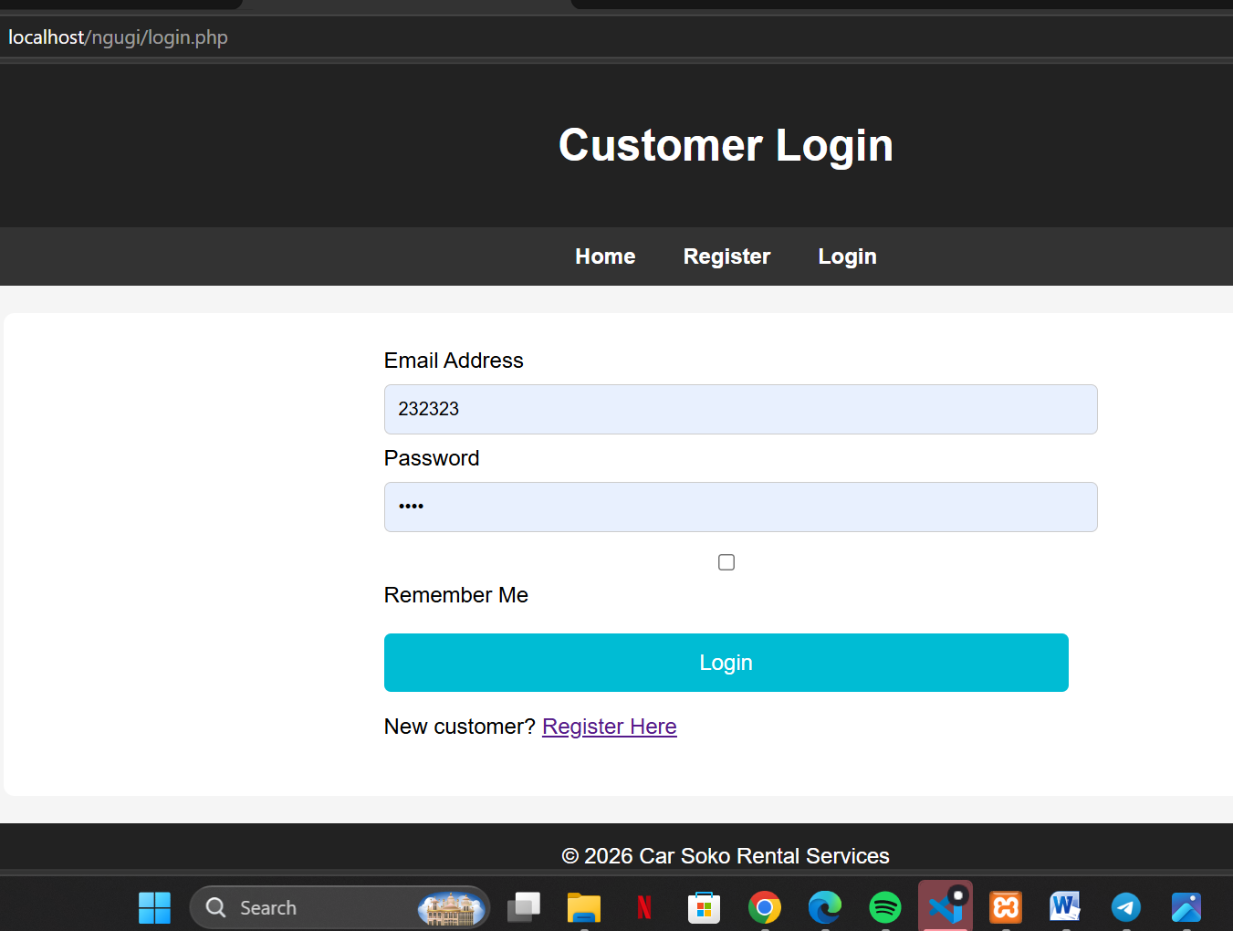

CONCLUSION
The website was tested for functionality, usability, and compatibility. All test cases passed successful. The registration,login,database connection, and home page operate as expected across different browsers and devices.

